ONLINE ELECTION COMMISSION

MANAGEMENT SYSTEM

DELHI

Sofware Requirement

Team:

Rahul Kumar

12bce0427

Shivam Jain

12BCE0220

**Table of Contents**

1. Introduction 4

1.1 Purpose 4

1.2 Scope 4

1.3 Definitions, Acronyms and Abbreviations 4

1.4 References 4

1.5 Overview 4

2. Overall Description 5

2.1 Use-Case Model Survey 5

2.1.1 Actors 8

2.1.2 Use-Cases 8

2.1.3 Use-Case Risk List 8

2.1.4 Use-Case Specifications 8

2.1.4.1 Vote 8

2.1.4.2 Save 10

2.1.4.3 Update 11

2.2 Assumptions and Dependencies 12

3. Specific Requirements 12

3.1 Functionality 12

3.2 Usability 12

3.3 Reliability 12

3.4 Performance 12

3.5 Supportability 12

3.6 Design Constraints 12

3.7 Online User Documentation and Help System Requirements 13

3.8 Purchased Components 13

3.9 Interfaces 13

3.9.1 User Interfaces 13

3.9.2 Hardware Interfaces 13

3.9.3 Software Interfaces 13

3.9.4 Communications Interfaces 13

3.10 Licensing Requirements 13

3.11 Legal, Copyright and Other Notices 13

3.12 Applicable Standards 13

4. Product Acceptance Criteria 13

4.1 Functionality Available In Version 1.0 13

**Software Requirements Specification**

**1.Introduction**

**1.1 Purpose:**

This Software Requirements Specification document describes the behavior and requirements of the “Election Management System” software package.

1.2 Scope

This SRS document applies to the “Election Management System” software package

## 1.3 Definitions, Acronyms and Abbreviations

Admin: An administrator.

Candidate: A person who seeks or is nominated for an office.

Cast: The process by which one voter id generated

Database: A collection of data arranged for ease and speed of retrieval or search.

Election: The selection of a person or persons for office by vote, or a public vote on a proposed submittal.

Electorate: The body of persons enlisted to vote in an election.

Jurisdiction: The territory over which an election occurs.

Poll: The place where votes are taken.

Referendum: A measure proposed or passed by a legislative body to the vote of the electorate for approval or rejection.

## 1.4References

None.

## Overview

The remainder of this document identifies the actors, use-cases, use-case scenarios, activity diagrams, assumptions and dependencies needed for the analysis and design of the “Election Management System” software package. All diagrams conform to UML standards

# Overall Description

## Use-Case Model Survey

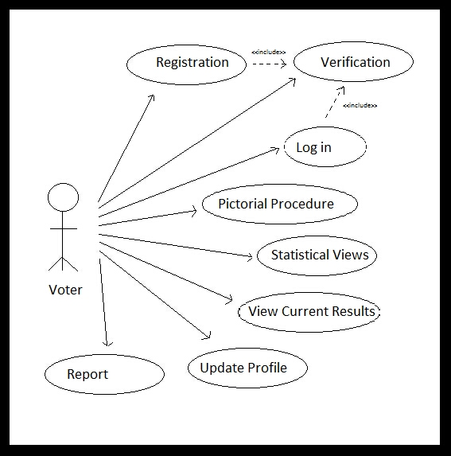

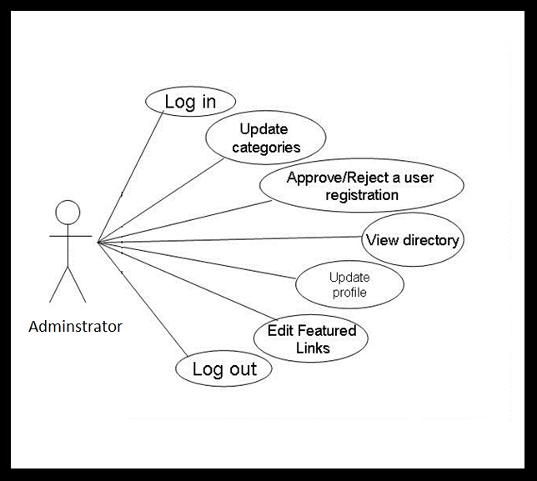

**Fig2-Administrator model**

### Actors

Voter: A member of the electorate, one who uses the “Electronic Commission Management ” software to form a voter card

Admin: A hired employee or volunteer for the agency sponsoring a vote, one who administrates the “Election Management Commission” software.

Database: A database for storing of sensitive vote id information and officer information.

Printer: A secure printer.

### Use-Cases

Voter id : This use-case describes the process by which a voter id creation.

Activate: This use-case describes the process of verifying a voter’s eligibility to vote. It ensures the voter is a member of the electorate.

Save: This use-case describes the process by which the system securely records a voter’sinformation to the database.

Print: This use-case describes the process the system uses to print a paper record, or audit trail, of a voter’s information.

Info: This use-case describes the process through which a voter may obtain vote-specific information during the general voter id procedure.

Update: This use-case describes the process by which an admin may add, remove or update voter id information

Initialize: This use-case describes the process through which the system first initializes during startup.

Login: This use-case describes the process of verifying an administrator’s identity. It ensures that the admin is allowed access to the non-voting capabilities of the “Election management System” software package.

### Use-Case Risk List

Highest: Vote, Save

Average: Update, Info, Print

Lowest: Initialize, Activate, Login

### Use-Case Specifications

### Vote id and Admininstratotor

* **Brief Description**

This use-case describes the process by which a voter id creation

* **Actors**

Voter

* **Dependencies**

Activate, Save, Print, Info

* **Basic Flow of Events: Voting, No Changes**

1. The use-case begins when a voter selects “Vote id creation”.
   * The system verifies the voter through the “Activate” use-case.
2. While there are more items on the Voter id
   * The system displays the current voter item fill and options.
   * The voter selects an option.
   * The voter presses the “Submit ” button.
   * The system retrieves the voter if information

**Administrator**

* Add New voter id
* Remove voter id information
* Change voter id content
* Assign the police officer duty according to their rank.
* View Online Help

### Save

* **Brief Description**

This use-case describes the process by which the system securely records a voter’s id information to the database.

* **Actors**

Database

* **Dependencies**

None.

* **Basic Flow of Events: Saving, No Errors**

1. The use-case begins when called from the “Voter id ” use-case.
2. The system checks the voter id and choices for data integrity.
3. The system creates a voter id record.
   * The system calculates a unique record signature.
4. The system encrypts the record.
5. The system adds the record to the Database.
   * The system checks to verify that the record was saved correctly.
   * The system checks the Database to ensure there is enough space for the next record.
6. The system displays a message confirming the voter’s ballot has been cast.
7. The use-case ends.

### Update

* **Brief Description**

This use-case describes the process by which an admin may add, remove or update voter id and officer location items.

* **Actors**

Administrator

* **Dependencies**

Login

* **Basic Flow of Events: Update, Multiple Ballot Items**

1. The use-case begins when an admin selects “Update”.
   * The system verifies the admin through the “Login” use-case.
2. While the admin does not press the “Logout” button:
   * The system displays options for possible administrative action.
   * The admin presses the “Update voter id Item” button.
   * The system displays a list of voter id to be updated.
   * The admin chooses a voter id and officer information
   * The admin enters new information for the ballot item.
   * The admin presses the “Update” button.
3. The system closes the session.
4. The use-case ends.

## Assumptions and Dependencies

* The Database system is fully functional and has enough space for at least 100 voter id.
* It can store at least five polling station officer information.
* The Printer device is fully functional and has the capability to print at least one audit trail.

# Specific Requirements

## Functionality

1. **The details about the related constituencies of the district.**
2. **The details about the polling booths in the respective constituency such as normal booths, sensitive booths, hyper sensitive booths.**
3. **The details of the EVM Machine is fed into the computer.**
4. **The Voter id creation**
5. **officers such that non of the polling officers will have the duty in their residential area and their working area**

* be possible through special means.

## Usability

* A voter may only create a one voter id if they are eligible to vote.
* A officer place at only polling both.

## Reliability

* The “Election management System” software will be available for voter use only during normal aelection During this time it shall be operational for as long as is possible.
* Administrators will have 24 hour access to the system.

## Performance

* The “Election management System” software package will perform all functions with minimal delay from the time of the initial request.
* The software will only accommodate one user at a time. No simultaneous use of the system by multiple voters, administrators, or a combination thereof shall be allowed.

## Supportability

The “Election management System” software shall have a clear and easily maintainable interface for managing election specific updates.

## Design Constraints

Due to the sensitive nature of the information handled by the “Electronic Voting System” software, a good deal of specific design constraints will be taken into consideration:

* The system shall only have the ability to write voter id (not read).
* The system shall not have the ability to overwrite any previously written voter id.
* Officer information.

## Online User Documentation and Help System Requirements

Documentation for the “Election management System” software package will be provided in the form of an online help manual, accessible directly from any portion of the user interface. Two distinct variations will exist:

* The voter manual will cover, in detail, the process by which a voter chooses district confirms their selections, makes corrections if necessary, and make a voter card This manual will be accessible to all users of the system.
* The system support manual will describe the steps necessary for a system administrator to add, remove or change a ballot entry - along with all other administrative functions. This manual will only be accessible to system administrators when properly logged in.

## Purchased Components

None.

## Interfaces

### User Interfaces

The “Election management System” software user-interface will be ADA compliant and otherwise easy to use for the general electorate.

### Hardware Interfaces

None.

### Software Interfaces

The “Election management System” software will interface with a local SQL database for writing and verifying voter id -records. Commands for interfacing, connecting and writing data entries will be the same as any standard SQL client-server application.

### Communications Interfaces

The “Election management System” software will communicate with a local printer to facilitate printing of an audit trail, or physical vote summary, during the vote process. Communication interface will be provided by standard operating system calls.

## Licensing Requirements

None.

## Legal, Copyright and Other Notices

None.

## Applicable Standards

None.

# Product Acceptance Criteria

## Functionality Available In Version 1.0

**Voter**

* Activate
* Make voter id
* Print Record
* View Voter id Information
* View Online Help

**Administrator**

* Add New voter id
* Remove voter id information
* Change voter id content
* Assign the police officer duty according to their rank.
* View Online Help